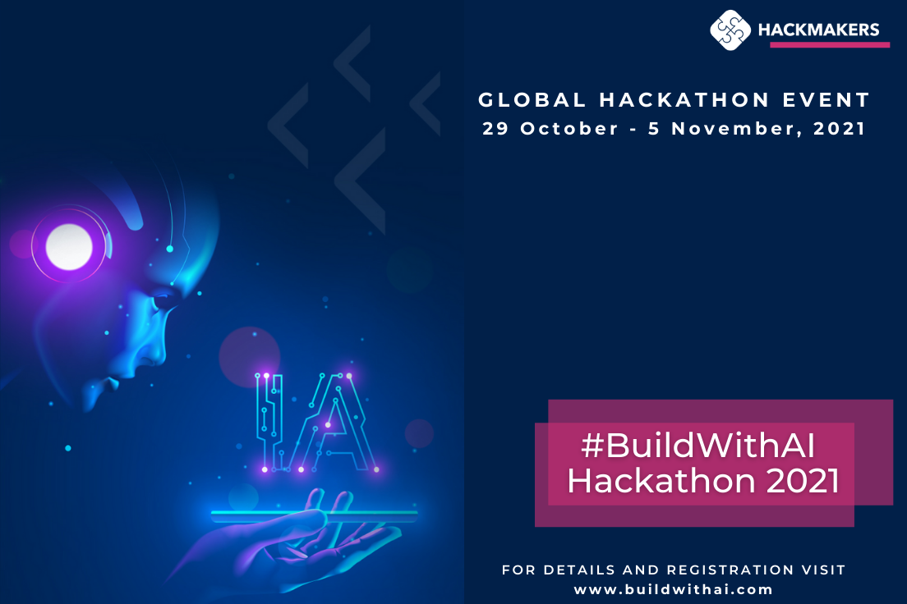

**We.The.World.AI**

**Who are we**

|  | **Name & email** | **Location** | **Role & Skills** |
| --- | --- | --- | --- |
| **We.The.World.AI** | | | |
| **1** | **Danielle Alice Desanges Aucéane**  **THIAM MÉKÀ de GOGUENHEIM**  [**thiam.meka.2.goguenheim@gmail.com**](mailto:thiam.meka.2.goguenheim@gmail.com) | **Yaoundé, CAMEROUN**  **UTC+1** | **Team Leader**  **Management, Ideation, Business, Presentation** |
| **2** | **Bennet CHEN**  [**bennett.chen@neurallab.io**](mailto:bennett.chen@neurallab.io) | **Sydney, AUSTRALIA**  **UTC+11** | **Presentation, Tech, Strategy, Business Models & Business Development** |
| **3** | **Qasid ALI**  [**qasidali768@gmail.com**](mailto:qasidali768@gmail.com) | **Lahore, PAKISTAN**  **UTC+5** | **Technical Lead Developer** |
| **4** | **Ilsa AFZAAL**  [**ilsaafzaal2142@gmail.com**](mailto:ilsaafzaal2142@gmail.com) | **Sargodha, PAKISTAN**  **UTC+5** | **Assist Technical Lead in team,**  **Assist Qasid Ali** |
| **5** | **Jean Bernard MATHIAS**  [**jeanbernard.mathias@gmail.com**](mailto:jeanbernard.mathias@gmail.com) | **Port Louis, MAURITIUS**  **UTC+4** |  |
| **6** | **Nnamse AKPAN**  [**akpan1ne@gmail.com**](mailto:akpan1ne@gmail.com) | **Cape Town, SOUTH AFRICA**  **UTC+2** | **Ninja** |
| **7** | **Allen FRIMPONG**  [**allen.frimpong24@gmail.com**](mailto:allen.frimpong24@gmail.com) | **New York City, USA**  **UTC-4** |  |
| **8** | **Poonam AHUJA**  [**ahujaps@uci.edu**](mailto:ahujaps@uci.edu) | **Michigan, USA**  **UTC-4** |  |
| **OUR AMAZING MENTORS** | | | |
| **1** | **Sydney NURSE** | **SWITZERLAND** |  |
| **2** | **Jason LOWE** | **AUSTRALIA** |  |
| **3** | **Himanshu JOSHI** | **USA** |  |
| **4** | **Sana MARZUMDA** | **INDIA** |  |
| **5** | **Tina RICH** |  |  |
| **6** | **Bilaji MUNUSAMY** |  |  |
| **7** | **Vikram** |  |  |

**Our Purpose**

**Challenge #3: ZERO HUNGER ZERO WASTE**

**How NGOs can leverage AI**

**Problem Statement:**

**Empathy Map**

**Used to develop a deep, shared understanding and empathy for other people, an Empathy Map is a tool that helps describe aspects of a user's experience, needs and pain points. This template allows us to quickly understand your AGA’s experience and mindset, this understanding will allow us to craft the genuine solution for our user, AGA.**

**More details on the problem statement in the document delivered by the organizers in the following link:**

[**https://buildwithai2021.slack.com/archives/C02GVDBGRPH/p1635708954022400**](https://buildwithai2021.slack.com/archives/C02GVDBGRPH/p1635708954022400)

**Find the Empathy Map of AGA on the presentation in the link below:**

[**https://docs.google.com/presentation/d/1CutH_CbrSjrwKF5zH_DW9HDyn70e6p6KyOsUEl9ZGJk/edit?usp=sharing**](https://docs.google.com/presentation/d/1CutH_CbrSjrwKF5zH_DW9HDyn70e6p6KyOsUEl9ZGJk/edit?usp=sharing)

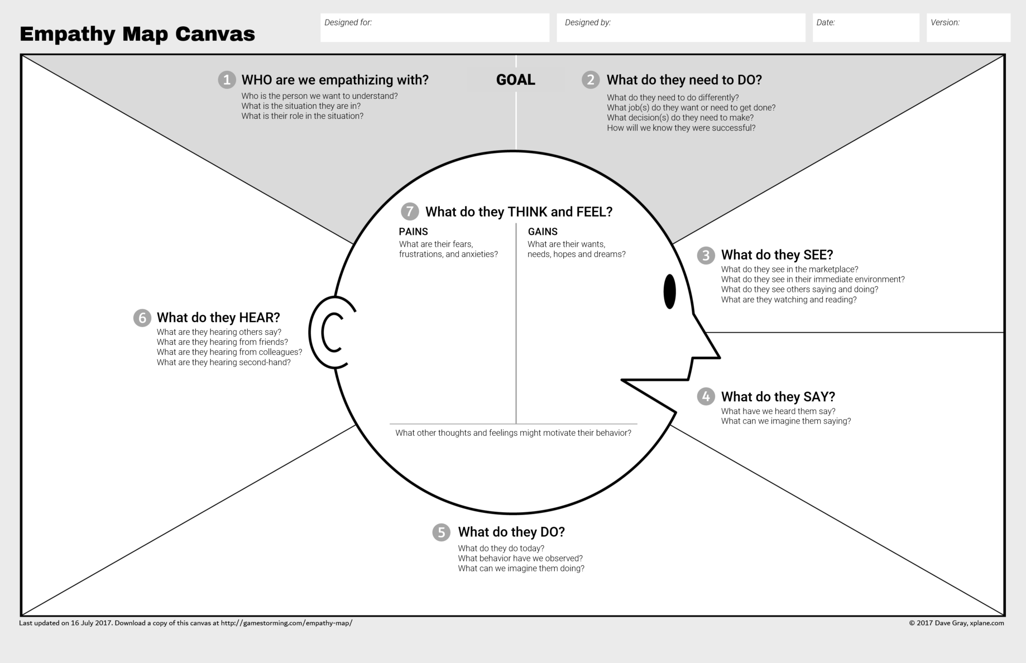

**Solution Statement:**

**We’re providing AGA with an AI-driven application called Preserv. AGA is trying to reduce the unwanted donations they receive from partners, also they are trying to support the vulnerable communities and families that rely on them to better utilize the donations given to them.**

**AGA’s biggest problem is their inability to**

**analyze and visualize data,**

**and to provide predictions based on the trends they discover, in order to suggest operational changes, and build processes that will efficiently improve their goal achievement.**

**The use of this digital platform will definitely help AGA to eliminate if not at least reduce both hunger and food waste within their community.**

**Value Proposition Canvas VPC**

**We use the Value Proposition Canvas to ensure there is a fit between the product and market by exploring the relationship between a Customer’s needs and the value proposition of the organization.**

**We will understand how AGA makes decisions and what offers to create that they will find appealing for the achievement of their goals.**

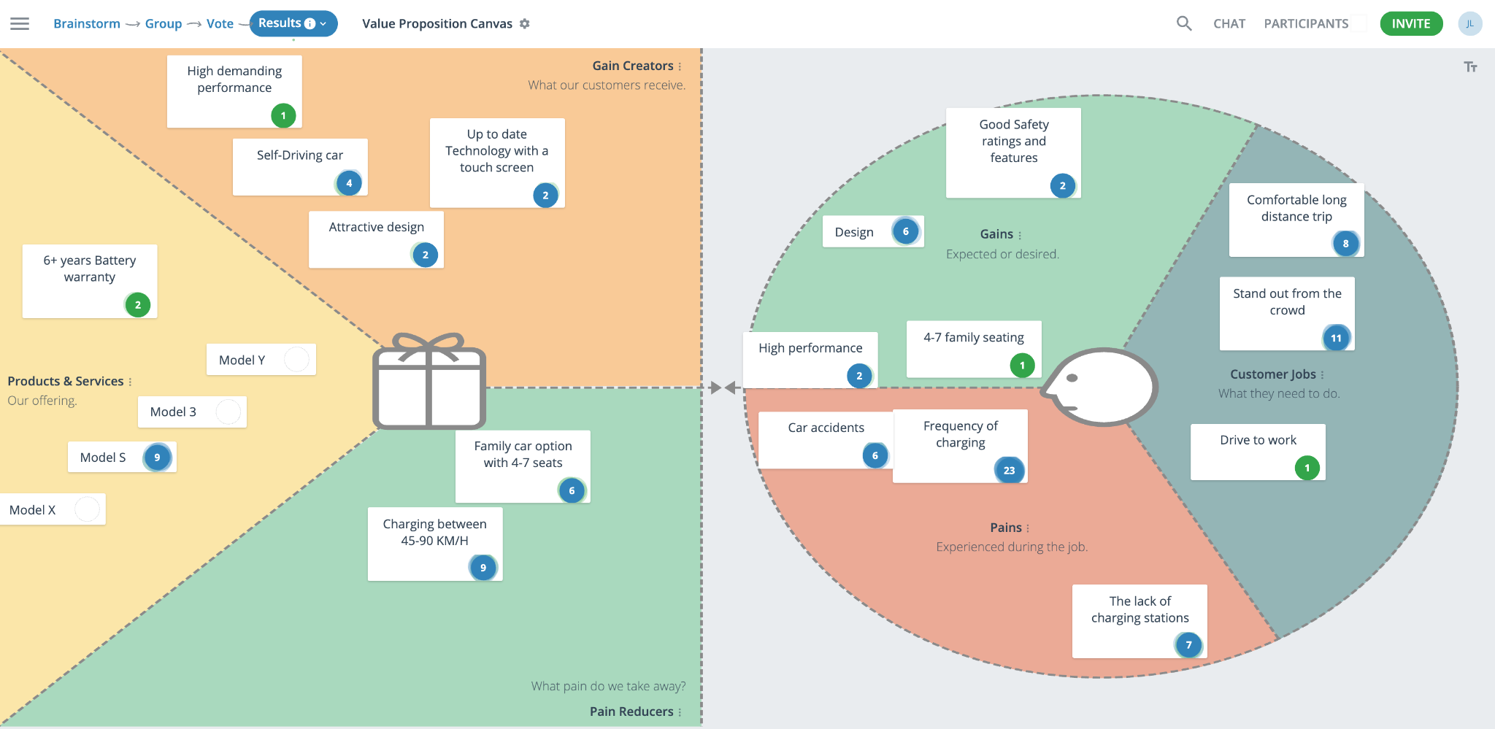

**Sustainable Business Model Canvas SBMC**

**AGA’s main goal in their activity is to contribute in achieving the SDG Target 12.3 by 2030 for the government of Australia.**

**In this way we develop our project/idea into a Sustainable Business Model. It follows a holistic approach regarding the relationships within and outside the business:**

**on one hand, AGA will leverage the**

**Besides economic criteria it focuses on ecological and social consequences of the activity. It aims at maximizing positive and avoiding negative impact on society and nature. Therefore, sustainability is integrated into the core business we’re giving the opportunity to AGA to contribute to.**

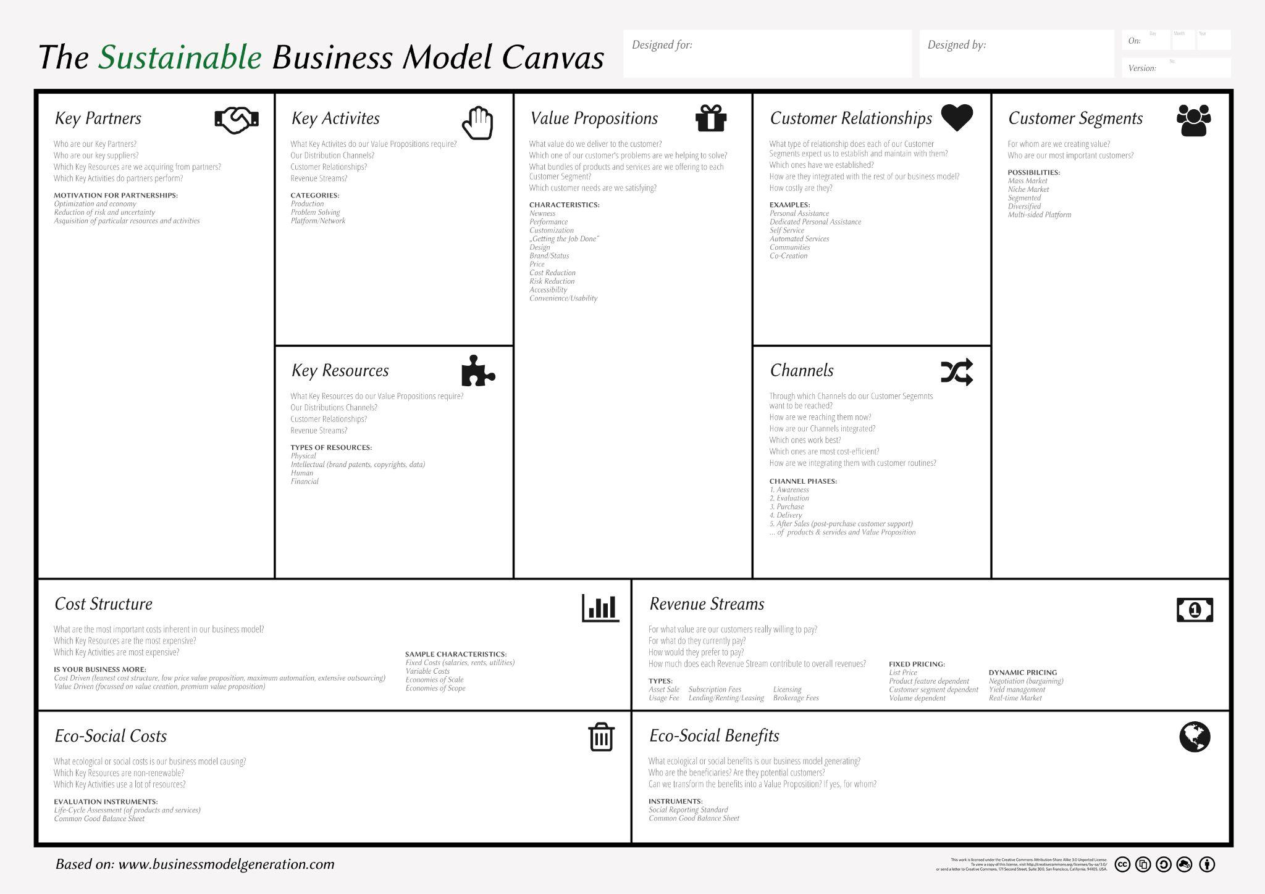**.**

**Machine Learning Canvas MLC**

**The Machine Learning Canvas is a framework to connect the dots between data collection, machine learning, and value creation**

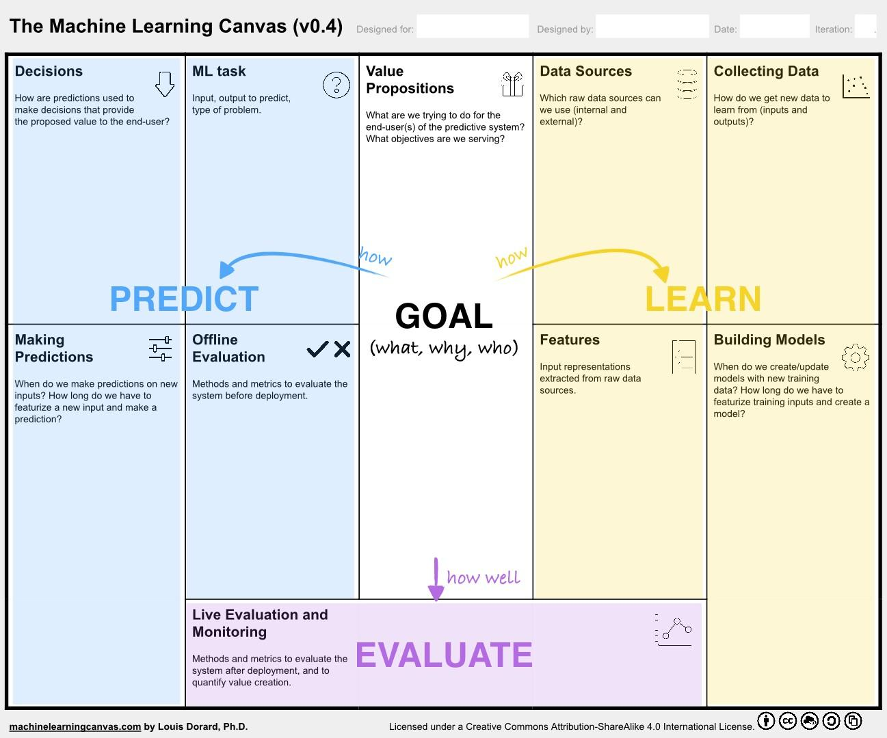

**This App platform facilitates exchanges by reducing transaction costs and/or by enabling externalized innovation and operates with a Sustainable Business Model**

**For this app to come to live, money has to be spent on:**

* **the payment of the developers**
* **the deployment in the OCI with a 70 percent of reduction on the Oracle Startup program**

**The data which this app collects and processes will be monetized to research institutions, marketers, and other organizations.**

**ExO Canvas**